1899 | Duelm Catholic Church fire.  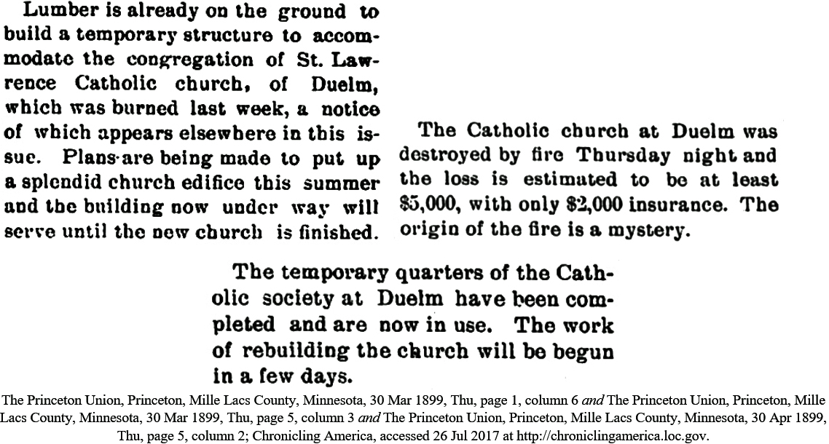  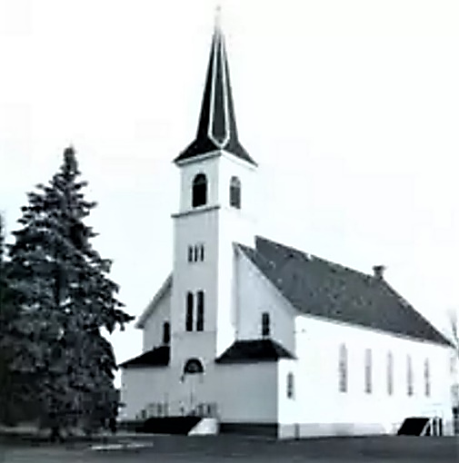  St. Lawrence Church, 1899-1985; founded in 1863.  Source, Church of St. Lawrence: Diocese of Saint Cloud at http://visitor.stcdio.org/st-lawrence-duelm-celebrates-sesquicentennial/; web site no longer accesible.

